Institute of Computer Technology

B. Tech. Computer Science and Engineering

Sub: DS Branch: BDA Class: A

Name: Jatin Patel

Enrolment No.: 23162121029

Sem: 3

Class: A

Subject: DS

Practical: 09

Date: 25/09/24

Write a program in C/C++ to create and display a Doubly Linked List.

Input data: 1, 6, 5, 9

Output: NULL > 1 > 6 > 5 > 9 > NULL

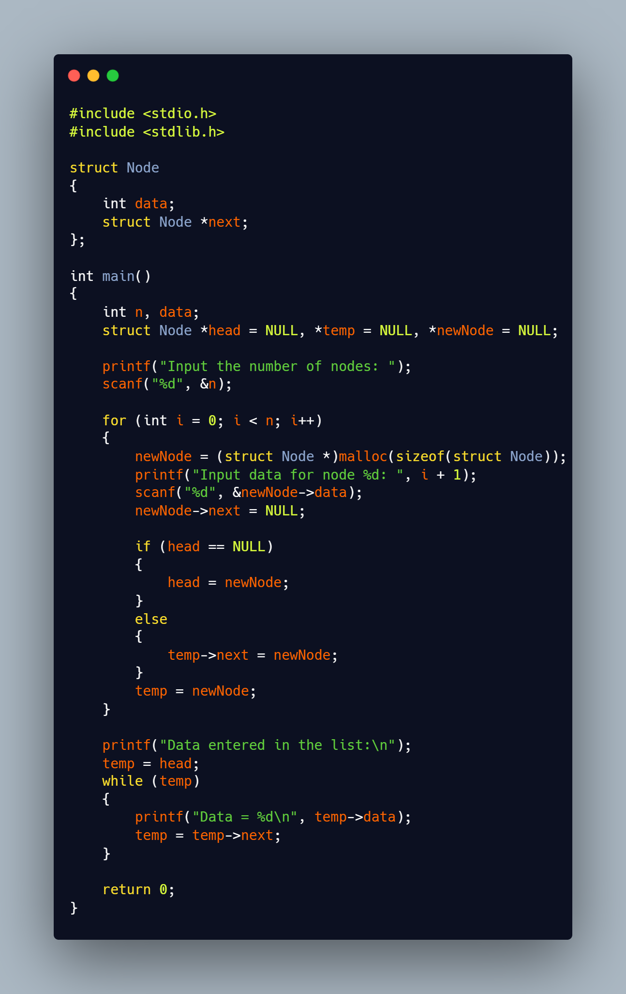

**Output:**

